SOCIAL MEDIA PLAN

Time Slot | Facebook Post Details | Twitter Post Details | Instagram Post Details
Day 1
9:30 AM | Post Title: Busy Morning? Us Too. <br> Content: That’s why we created ChewFit - the on the go solution to help you meet your weight loss goals. Try the #OneChewWonder  #ChewFit #Morning Routine <br> Visual Note: Image women on the go. | Post Title: Meet your new morning ritual: <br> Content: No pills, No powders, Just one easy chew & daily weight loss support #ChewFit #OneChewWonder <br> Visual Note: small visual | Post Title: Wellness shouldn’t be a full time job <br> Content: Weight Loss should fit your lifestyle - not disrupt it. Try the #OneChewWonder today #ChewFit #MorningRoutine <br> Visual Note: Same image as on facebook. The words “wellness shouldn’t be a full time job on top of the picture.
12:00 PM | Post Title: [Title] <br> Content: [Brief description] <br> Visual Note: [Image/Video] | Post Title: [Title] <br> Content: [Brief description] <br> Visual Note: [Image/Video] | Post Title: [Title] <br> Content: [Brief description] <br> Visual Note: [Image/Video]
4:30 PM | Post Title: Ingredient Spotlight! <br> Content: Caption: What makes ChewFit work? Ingredient 1 - breakdown, Ingredient 2 - breakdown, Ingredient 3 - breakdown.  Your goals, Your body, all made easy and accessible through ChewFit. #OneChewWonder #ChewFit <br> Visual Note: image showing breakdown of 3 ChewFit ingredients | Post Title: Real Ingredients <br> Content: Real ingredients. In case you didn’t know. # REALchew <br> Visual Note: text says REAL across the page, shows ChewFit bottle. | Post Title: Ingredient Spotlight! <br> Content: Aesthetic ingredient spotlight. Caption: Breakdown: Ingredient 1, Ingredient 2, Ingredient 3. REAL.  #OneChewWonder #ChewFit #REALchew <br> Visual Note: Image showing breakdown of 3 ingredients.
Day 2
11:30 AM | Post Title: Easy Breezy <br> Content: Where does it FIT in for you? Caption: Wake up, Coffee, One chew, Conquer the day. ChewFit makes it easy and breezy. No extra steps, no pills, no powder, no stress.  #OneChewWonder #EasyBreezy #ChewFit <br> Visual Note: [Image/Video] | Post Title: Easy Breezy <br> Content: Made for those who need weight loss to be easy breezy. #OneChewWonder <br> Visual Note: Where does it fit in for you? Easy breezy image | Post Title: Easy Breezy <br> Content: GRWM! “Get ready with me” ChewFit makes it easy and breezy. No extra steps, no pills, no powder, no stress.  #OneChewWonder #EasyBreezy #ChewFit <br> Visual Note: Video *not included* of a woman’s morning routine. Includes ChewFit.
5:00 PM | Post Title: Cut the Crap <br> Content: I Cut the Crap with ChewFit. Meet Mary, a 38 year old from Maryland. “As a busy mom, ChewFit was the only thing that fit my lifestyle.” #OneChewWonder #CutTheCrapWChewFit #REALchew <br> Visual Note: Mom pictured in workout clothes holding her child up. Cut the Crap and Meet Mary intext. | Post Title: Cut the Crap <br> Content: Cut the Crap. REAL Stories from REAL users. Tap the link in bio for more  #OneChewWonder  #CutTheCrapWithChewFit  #REALchew <br> Visual Note: Image is animated and reads “cut the crap.” | Post Title: Cut the Crap <br> Content: [I Cut the Crap with ChewFit. Meet Kacey, a 31 year old from NYC. “ChewFit didn’t just help me lose my weight – it helped me gain back my confidence.” #OneChewWonder #CutTheCrapWChewFit #REALchew <br> Visual Note: Professional shown at work. Cut The Crap and Meet Kacey intext.
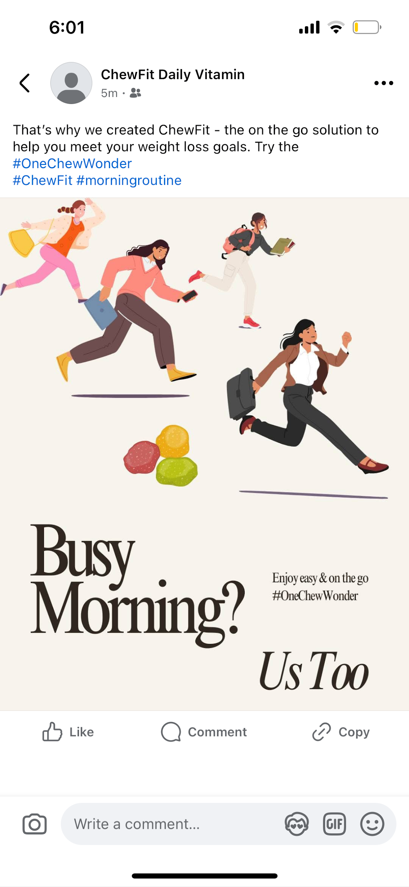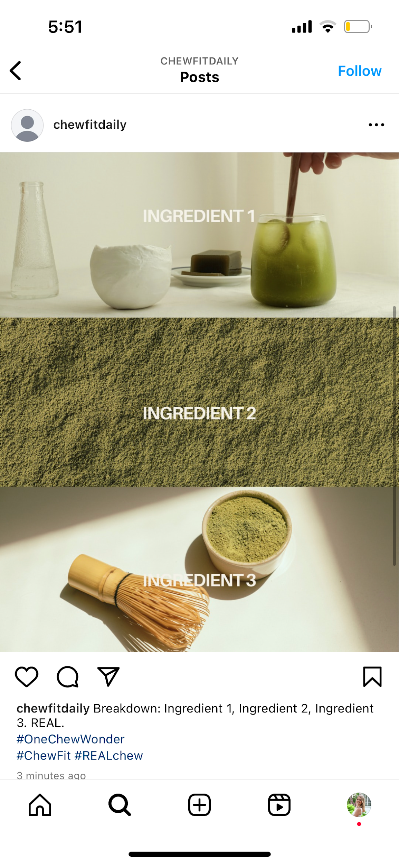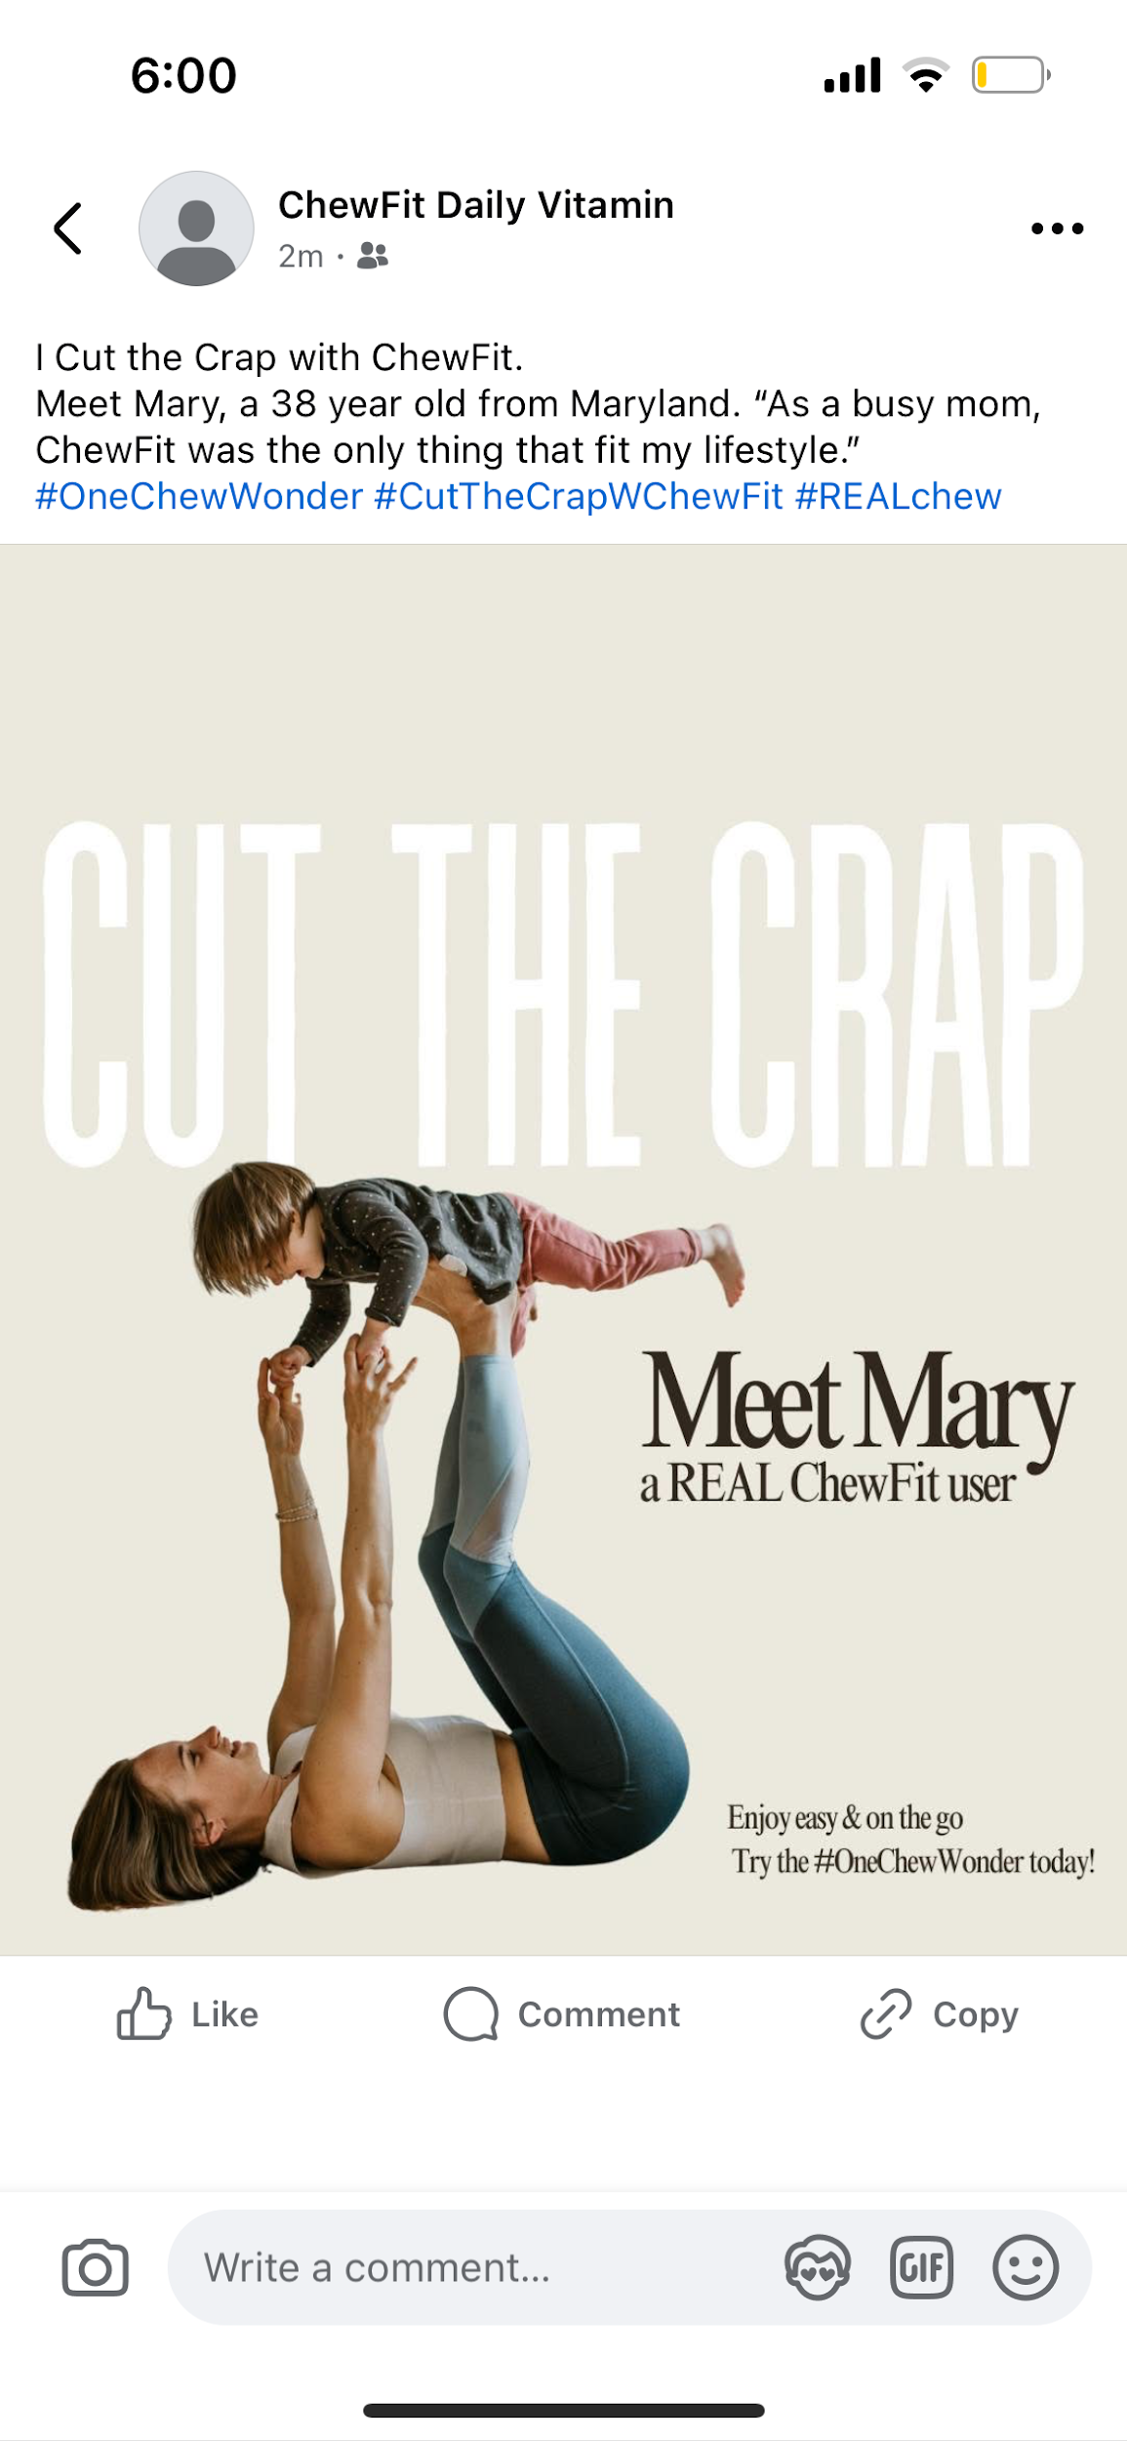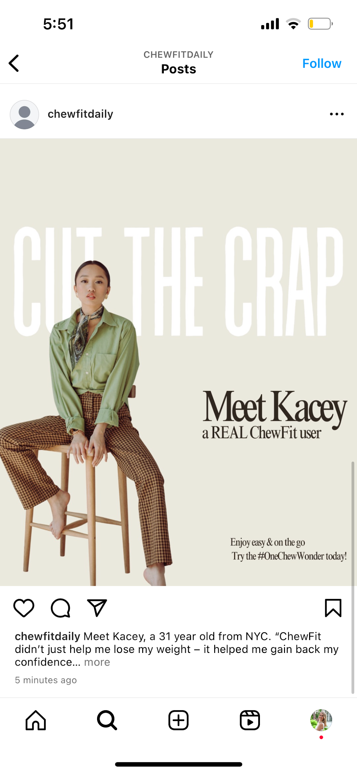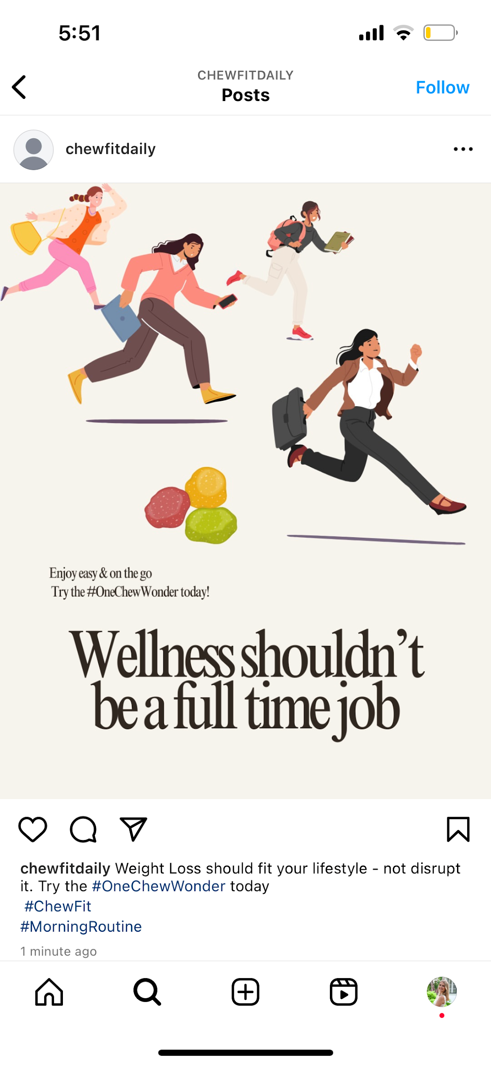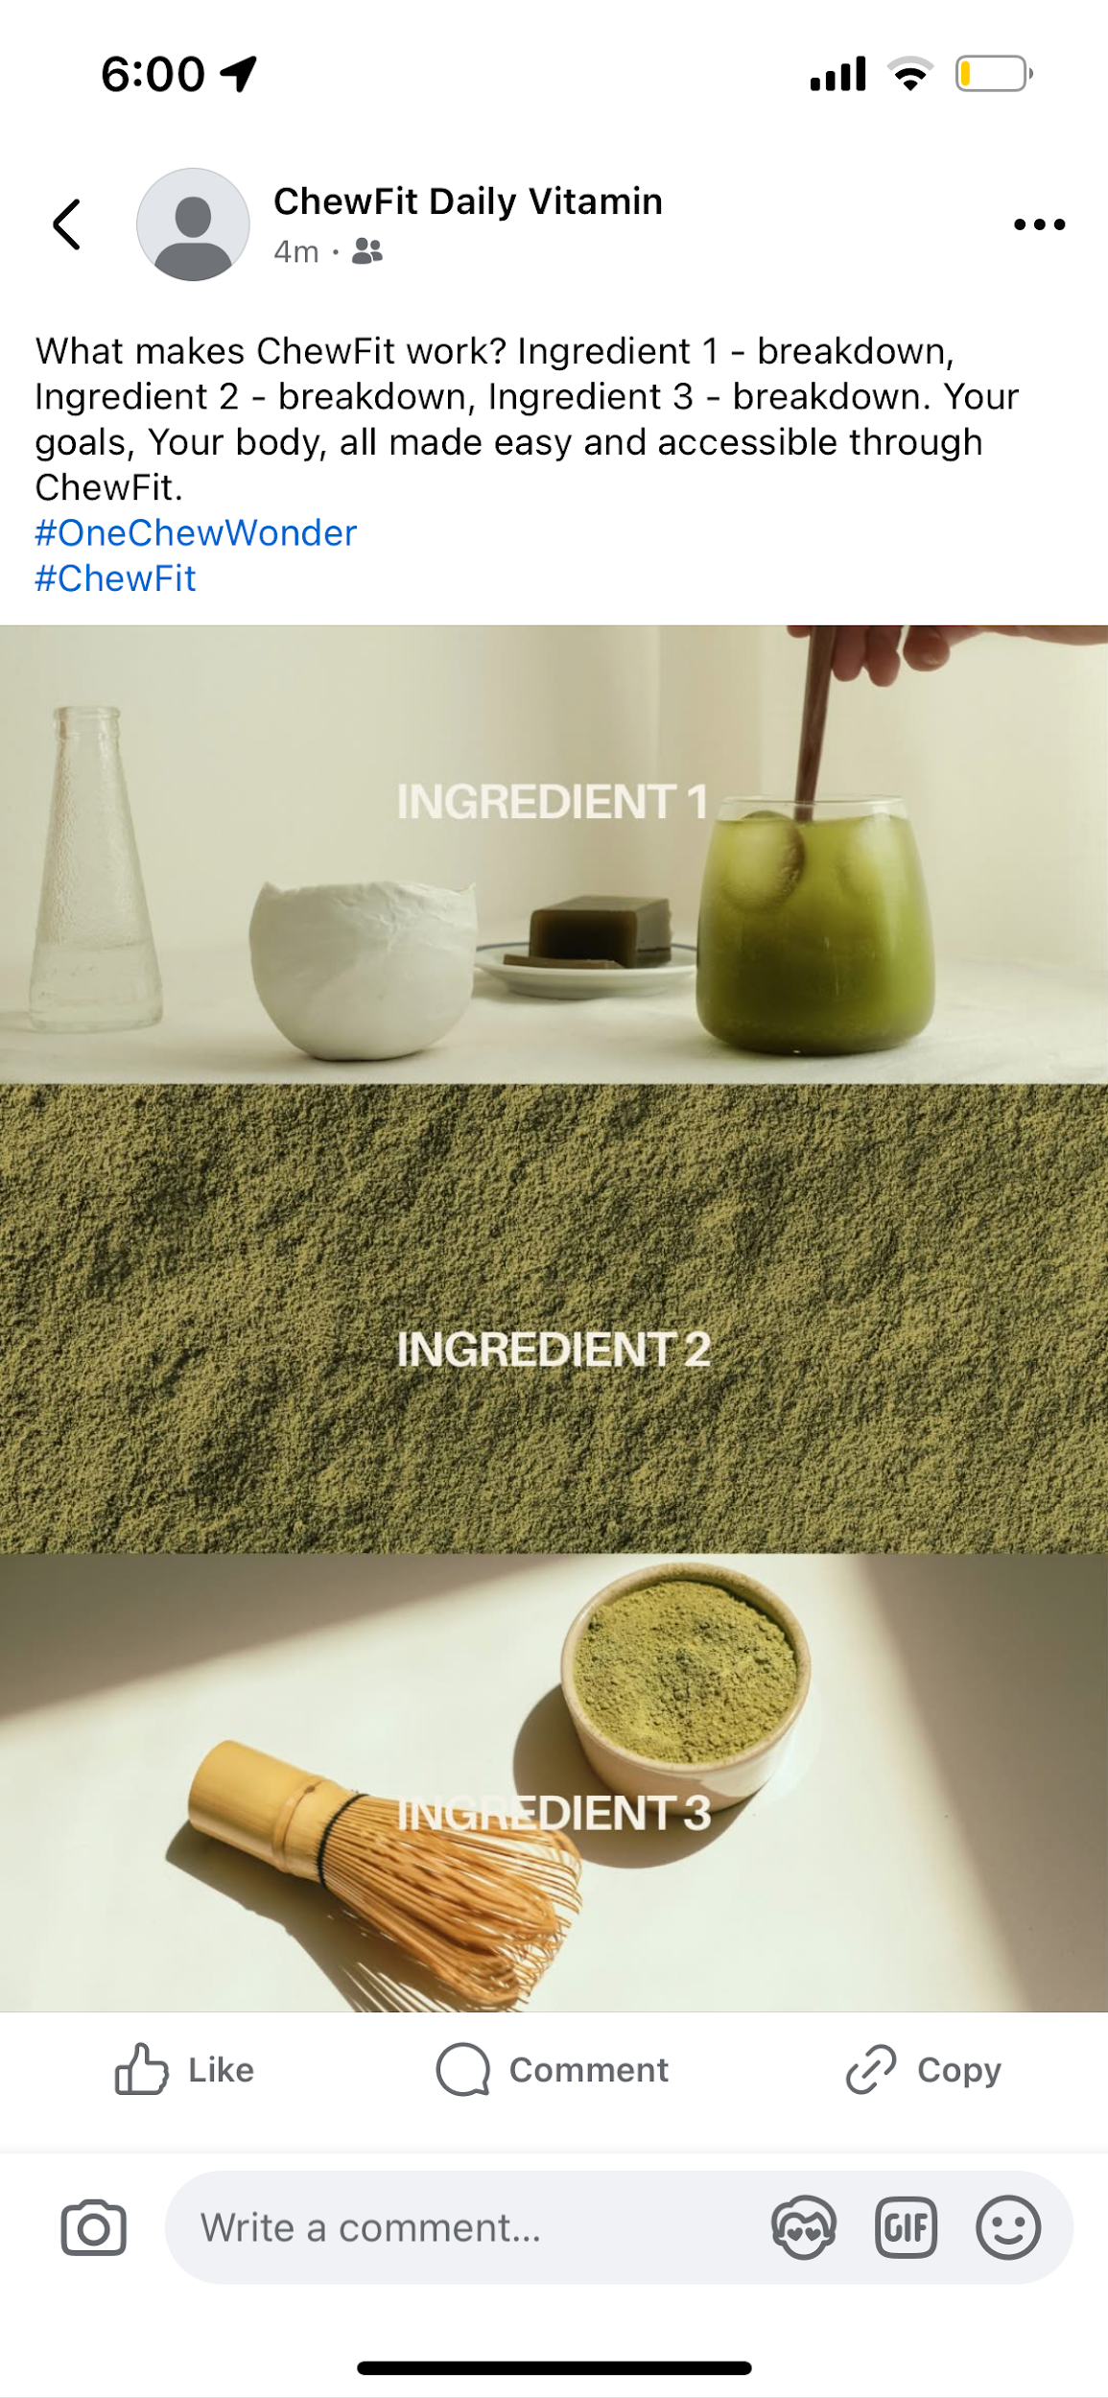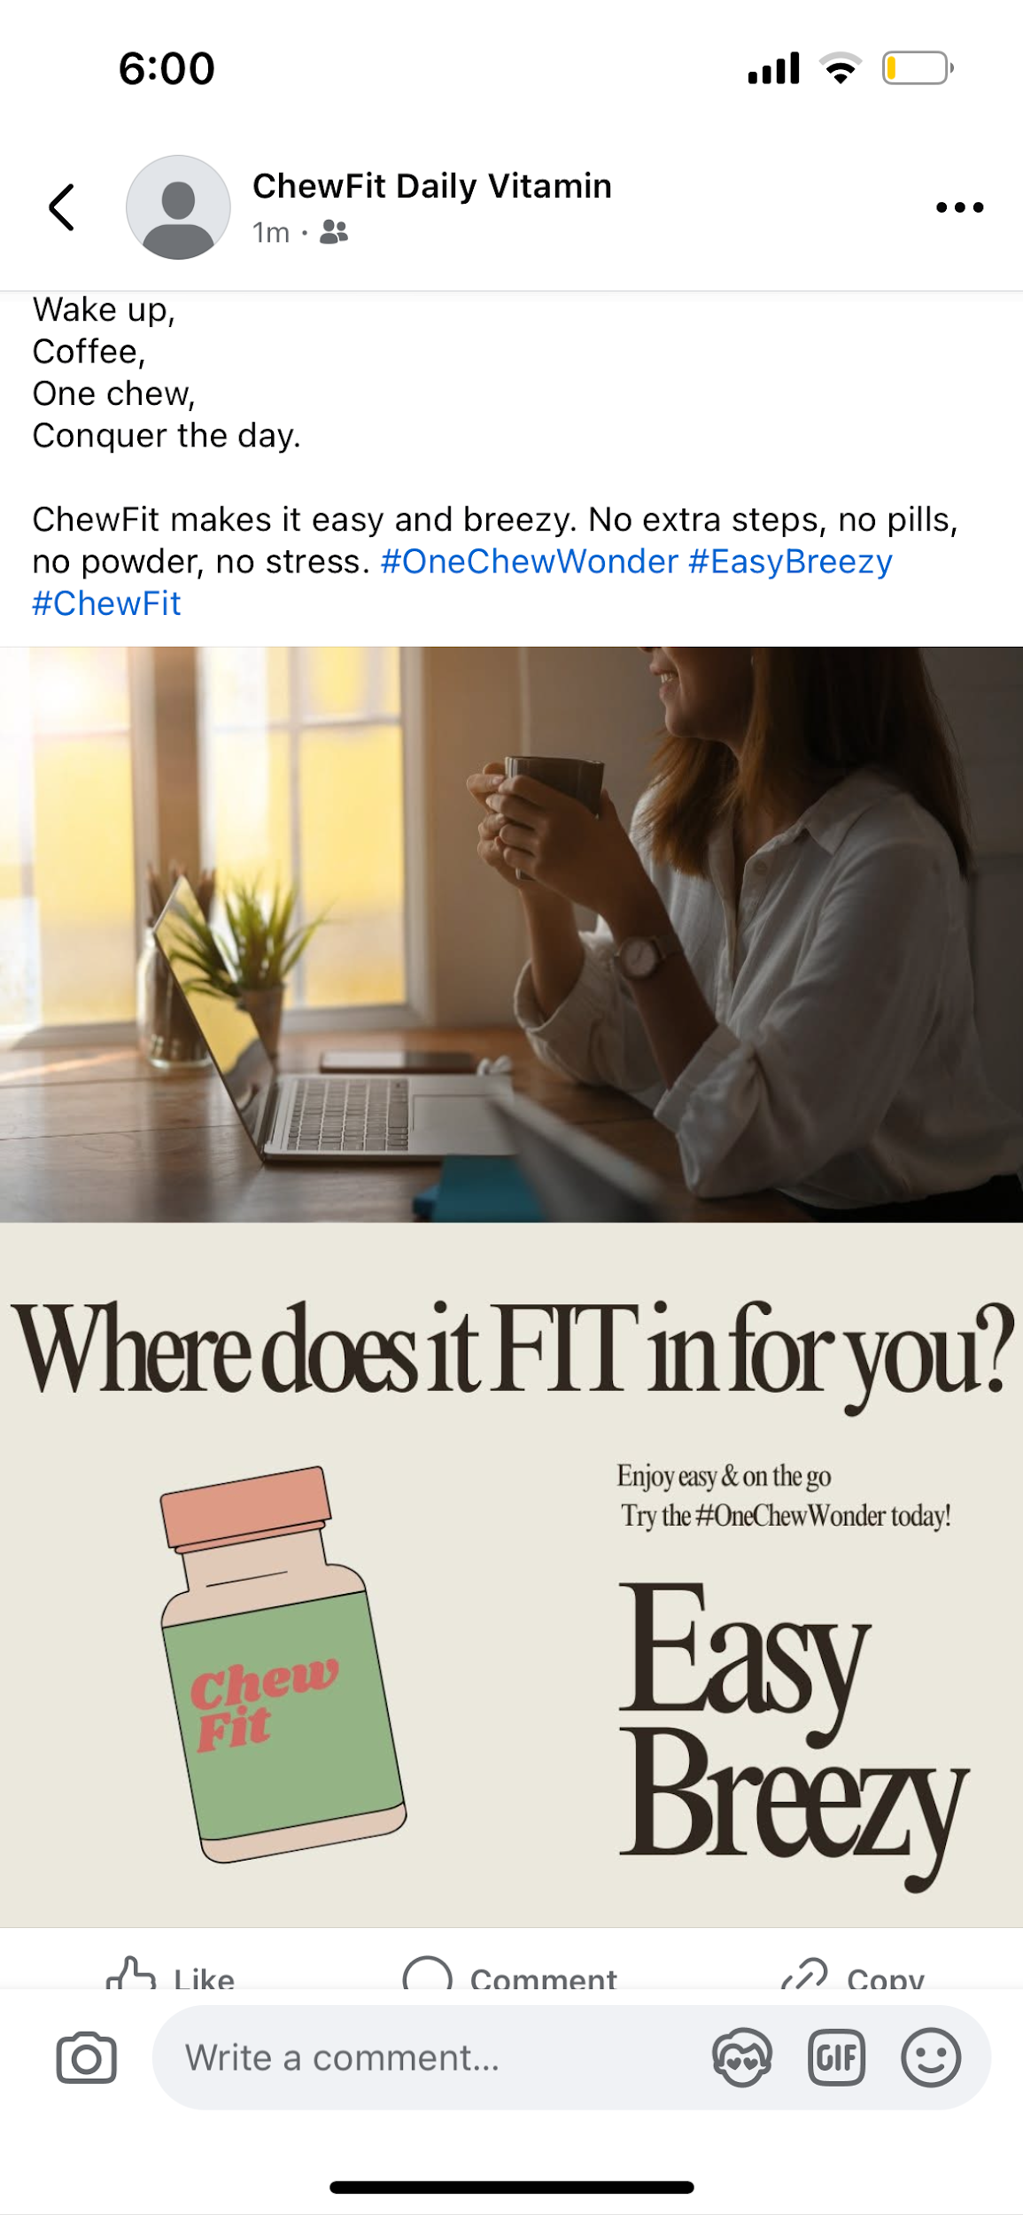
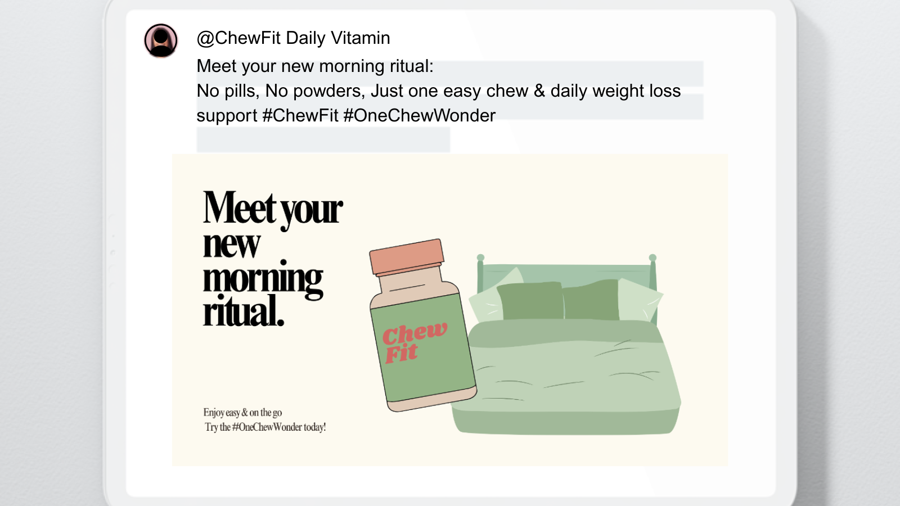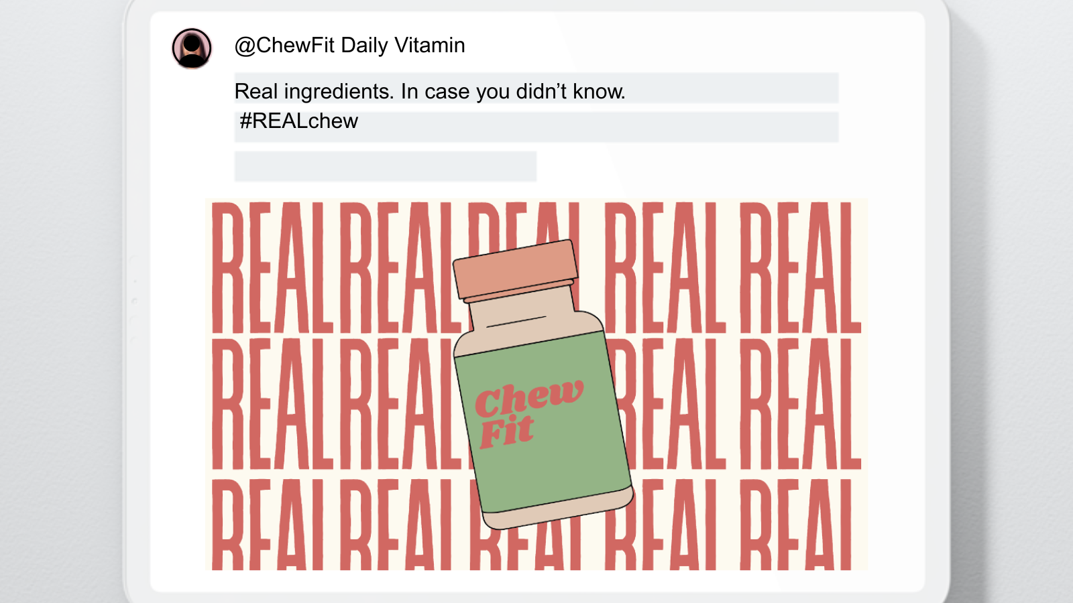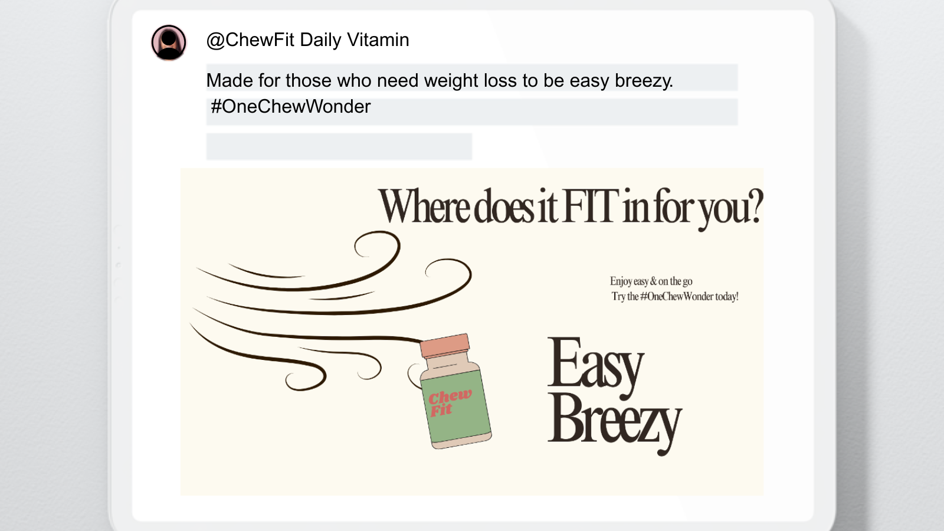
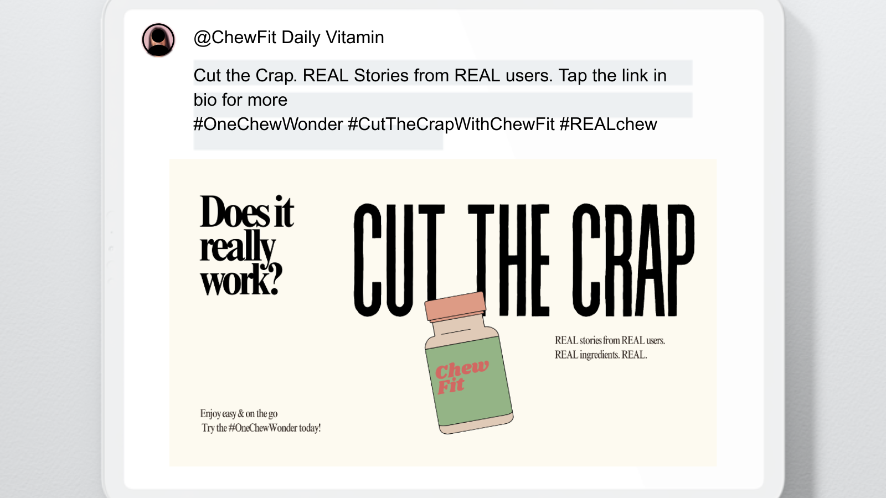

AUTHORS NOTE:
My vision with this campaign was to highlight the benefits and user stories from Chew Fit, through several cohesive campaigns. I think the brands profile should have similar posts on all platforms. However, I did intend for twitter’s posts to all fit the same theme as well. My main focus with cohesion was the overall message. When it came to twitter, I wanted each visual to look similar. When it came to Instagram and FaceBook, I wanted the individual posts to match them same theme and look similar. I also tried to execute this cohesion by using the same fonts and repeating the tagline in each post. The tagline is “enjoy easy and on the go. Try the #OneChewWonder today.” I think the repetition of this tagline and hashtag not only connects the posts but also creates brand recognition. I think this repetition of the tagline and hashtags will increase user recall. I went with the route of animated graphics on most posts instead of real-looking photos. I did this to create more of a playful persona with the brand. I think this is pretty trendy right now for companies.

When uploading these mock-ups to potential accounts I ran into issues with creating a mock-up twitter. I was unable to create a fake account or create a proper template. Instagram and Facebook’s mockups look official and I believe would be successful on ChewFit’s real accounts. After uploading my designs, I’m happy with the overall theme. I think the font I selected makes the posts cohesive throughout the different media outlets. This creates brand resonance and will have a lasting effect when it is reached. My one concern is the ingredient spotlight post. The reason I kept the aesthetic backgrounds on these is because I believe this post will do well on Instagram. I chose not to add the brand's tagline on this to keep it clean. I think this was a good choice. Overall, I am pleased with how my final draft turned out and I await to hear specific feedback.

